# Created by RickyQi

1.Download mininet VM

<http://mininet.org/download/>

* Import mininet to VMbox
* Set network to bridge mode
* Check IP in mininet VM

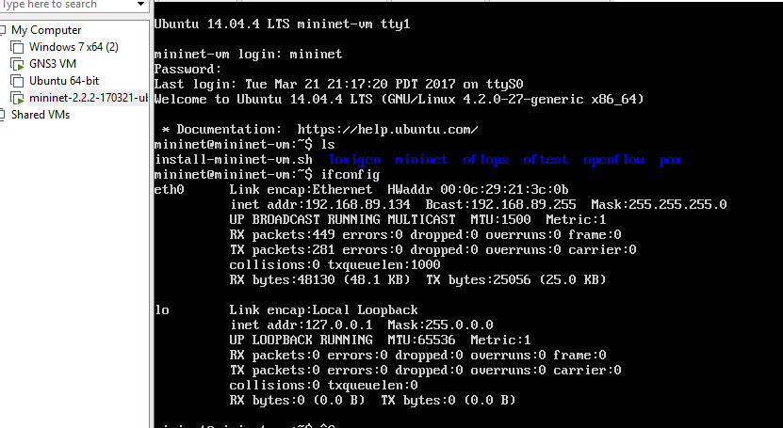

* Connect mininet through windows terminal

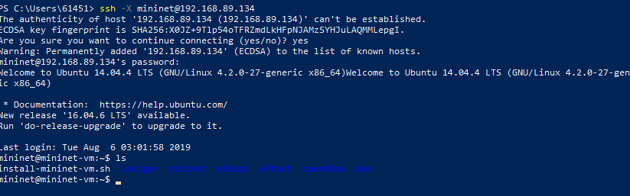

2.Install Opendaylight

* Download ubuntu-14.04.3-server-amd64
* Set network to bridge mode
* Install dependency

**apt-get update**

**apt-get install maven git openjdk-7-jre openjdk-7-jdk unzip**

* download opendaylight

**wget** [**https://nexus.opendaylight.org/content/repositories/public/org/opendaylight/integration/distribution-karaf/0.3.1-Lithium-SR1/distribution-karaf-0.3.1-Lithium-SR1.tar.gz**](https://nexus.opendaylight.org/content/repositories/public/org/opendaylight/integration/distribution-karaf/0.3.1-Lithium-SR1/distribution-karaf-0.3.1-Lithium-SR1.tar.gz)

* unzip file
* cd distribution-karaf-0.3.1-Lithium-SR1
* set java path

export JAVA_HOME=/usr/lib/jvm/java-1.7.0-openjdk-amd64

**Set network:**

sudo vi /etc/network/interfaces

# The loopback network interface

auto lo

iface lo inet loopback

# The primary network interface

auto eth0

iface eth0 inet static# set your own network address make sure your c#omputer and your VM in the same subnet

address 192.168.172.105

netmask 255.255.255.0

network 192.168.172.0

broadcst 192.168.172.255

gateway 192.168.172.1

dns-nameservers 8.8.8.8

**sudo shutdown -r reboot**

**cd unzip distribution-karaf-0.3.1-Lithium-SR1/bin**

**sudo ./karaf #start opendaylight**

**feature:install odl-restconf-all odl-l2switch-switch odl-dlux-all odl-mdsal-all**

3.Association

After we use mininet create a network then we can associate the opendaylight GUI API with mininet

then we can visit the website(remember set mininet remote addr for this address)

<http://192.168.172.105:8181/index.html>